**Aim**:Nagios.

**Objectives:**

* Set up Nagios on Ubuntu
* Monitor a Windows machine using Nagios
* Access the Nagios Dashboard

**Tools Used**: Virtual box, Ubuntu , Nagios

**Concepts:** Network Monitoring, Nagios Configuration, IP & Hostname Identification, Service Management

**Problem Statement:** To monitor a Windows machine using Nagios installed on Ubuntu.

**Process:**

Step 1: Check for the Nagios Directory.

$cd /usr/local/nagios/etc

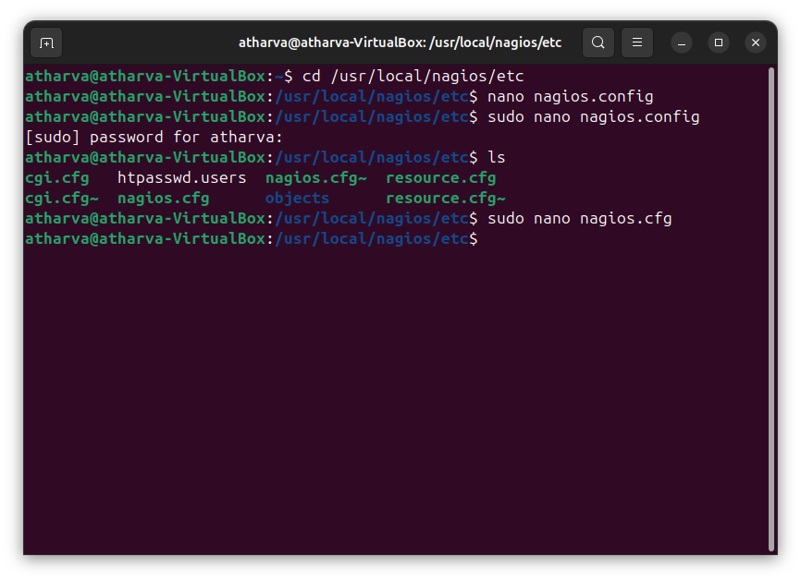

Step 2: Open nagios.cfg file

$nano nagios.cfg

Step 3: Remove the # sign for monitoring a windows machine.

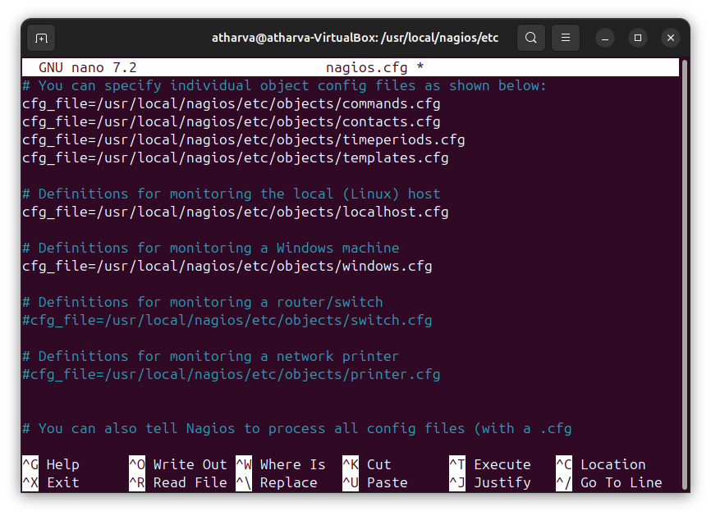

Step 4: Go to your windows machine and use the below command to find the IP address of the machine and the host name as well. $ipconfig /ALL

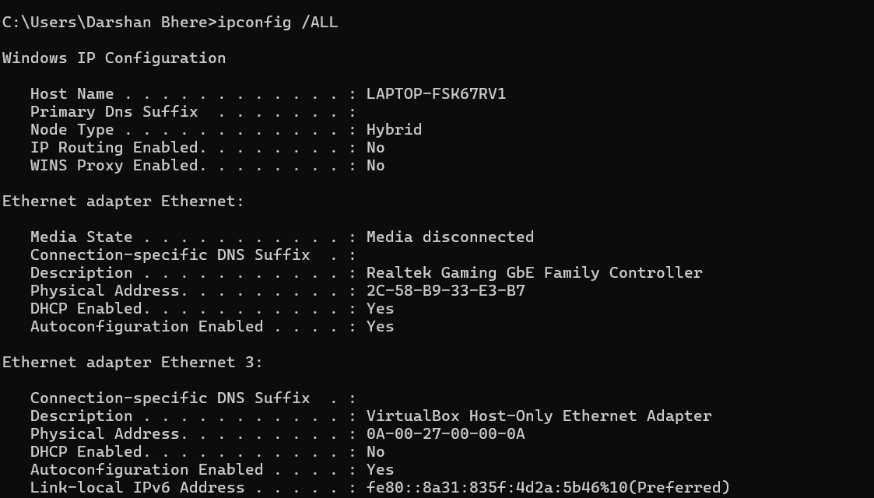

Step 5: While defining a service, rename the hostname as mentioned in your windows machine for all the defined services. Replace all the host_name with your windows machine host_name. Also replace the address with IP address of windows machine

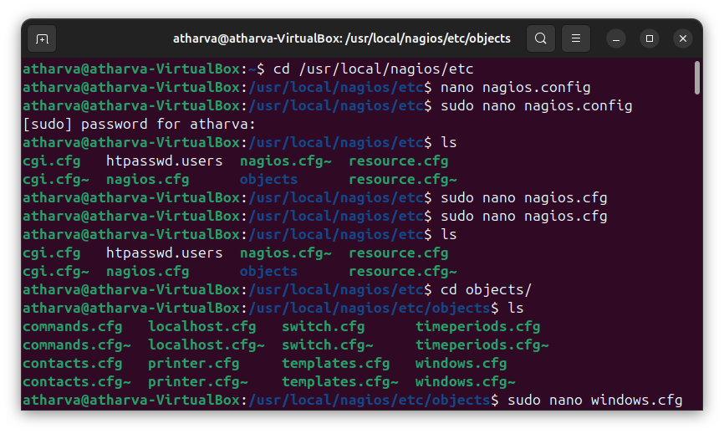

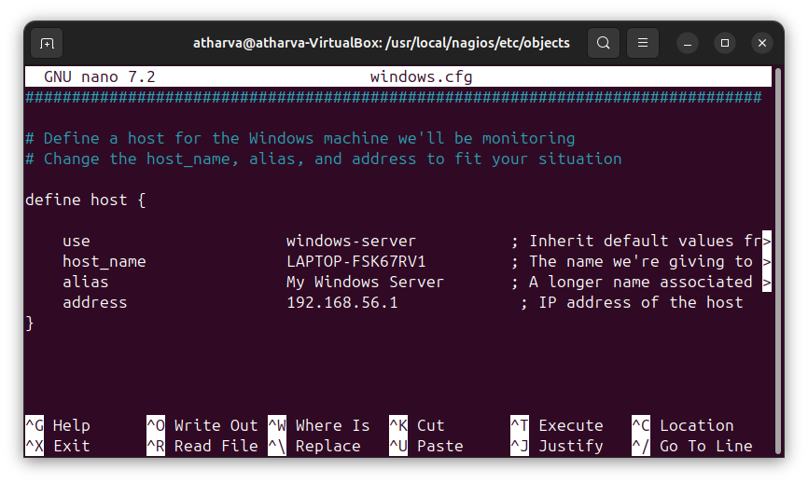

Step 6: Use the below command to identify the address on which Nagios is running:

$ip addr show

$service nagios start

$service apcehe2 start

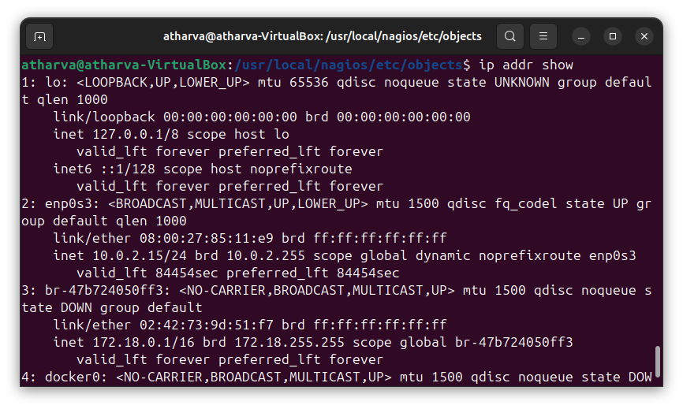

Step 7: Go to browser and open Nagios Dashboard in the browser. 172.18.0.1/nagios

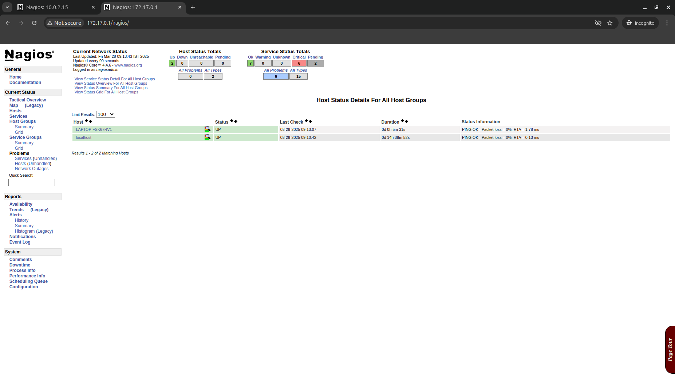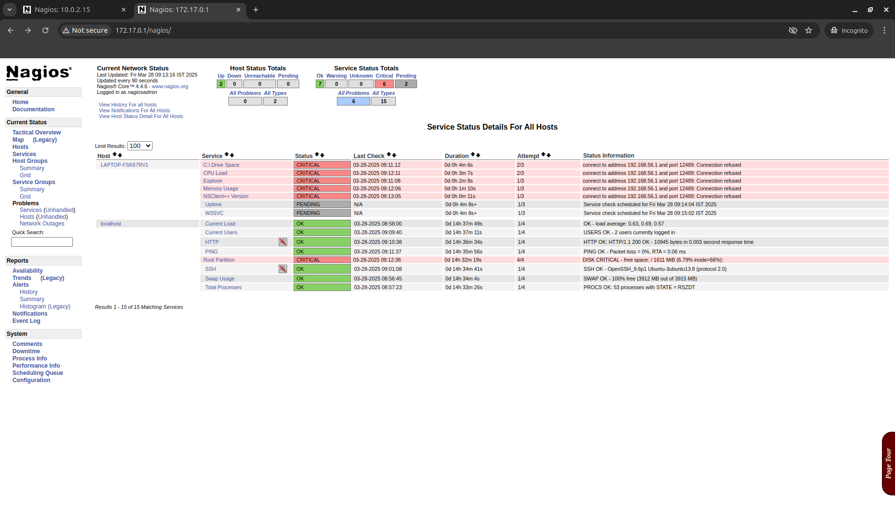

**Conclusion:**Nagios provides an efficient way to monitor system health and network resources. By configuring it to monitor a Windows machine, we gain real-time insights and alerts for better system management. This setup enhances proactive system administration.